Chandigarh College of Engineering

and Technology

(Department of computer science and engineering)



C++ Project on   
Supermarket Billing System

Submitted By:

Himanshu Setia (CO19328)

Kunwardeep Singh (CO19338)

**ACKNOWLEDGEMENT**

The credit for the successful completion of this project work goes beyond our own work, to those people who have always been with us throughout. And we take this opportunity to express our heartfelt gratitude to each one of them.

We express our sincere thanks to our Mentor Dr. Sarabjeet Singh of for his valuable suggestions and providing guidance throughout the project, that enabled us to complete this project successfully.

Abstract

Super Market Billing System The project is on Supermarket Billing. Supermarket is the place where customers come to purchase their daily using products and pay for that. So there is a need to calculate how many products are sold and to generate the bill for the customer.

To make software fast in processing, with good user interface so that user can change it and it should be used for a long time without error and maintenance.

Introduction

* Supermarket is the place where customers come to purchase their daily using products and pay for that.
* There is a need to calculate how many products are sold and to generate the bill for the customer.
* So for this we have created a project in c++ of the Supermarket billing system.
* The bill calculating operator will enter the unique code of product then it will show its information and price and the bill will be calculated and total payment will be shown.
* Customer will pay for the products.
* All the products sold history will be saved in master records file.

Description of the project

* Many Supermarkets use this type of billing system for a decade. It is also improved many times according to requirements of sellers and customers
* A new concept of editing and searching the goods is added in this project. With the help of this a customer can easily increase or decrease quantity of goods.

TECHNOLOGY AND TOOLS USED

In this project we have used C++ programming language for writing Source Code of this project.

The implementation of this source code has been done on free popular Open Source IDE “CodeBlocks”.

Features of C++ applied

* Classes and Objects
* Inline functions
* Inheritance
* Polymorphism
* File Handling
* Function Overloading
* Friend Function

Header files and functions used

In this project we have mainly used six main header files and many functions supported through these header files.

* iostream.h: cout, cin
* windows.h: SetConsole, system(“cls”), CursorPosition()
* conio.h: toupper(char), getch(), gotoxy(int,int), getche()
* fstream.h: fout.open(),fin.open(), fout.close(), fin.close()
* string.h: strcmp(const char *,const char *)
* stdio.h: fflush(FILE *stream)

Methods and functions

In this project we have used many functions that are user defined and are named as according to the function they performed. List of functions is given below:

* **fstream** : - The object declared for this class is fout and fin. It is the predefined class used for both File-to-Memory/Memory-to-File linking.
* **main()** : - This is the main function which is just the MAIN MENU from where the control is transferred to other functions.
* **gotoxy(intx,int y)** :- This function can place cursor at a desired location on screen.
* **security()** :- Security function for operating at billing counter by bill calculating operator.
* **starting_fun()** :-The starting function of the program which guides the user.
* **display()** :-Function for displaying options on screen.
* **search_goods(intnum)** :-Function used to search items from the choosen items.
* **search_goods_sub(intnum)** :-This function is part of previous function and it is a continuation of search_goods() function.
* **add_goods()** :-This function helps to add items to the bill.
* **heading()** :- Function for displaying heading on screen.
* **edit_goods(intnum)** :-This function edit added items details like quantity, price etc.
* **edit_goods_sub()** :-It is a continuation of edit_goods() function.
* **delete_goods(intnum)** :-Funtion to delete items from bill.
* **display_goods(intnum)** :-Function to display items on screen.
* **valid(int opt)** :-Function to check validation of options entered by user.

Benefits of this project

This project has been designed to provide ease to workers of such types of supermarkets and modify the already existing supermarket billing system. Some major benefits of this project are written as follows:

* Saving in labor due to self-service system.
* Supermarket has large turnover.
* Low cost of operation.
* Freedom of selection.
* Shopping is very easy and quick

Implementation

As mentioned above, Supermarket billing system is very much useable in the stores. So here are some snapshots below which will explain the working of executable file.

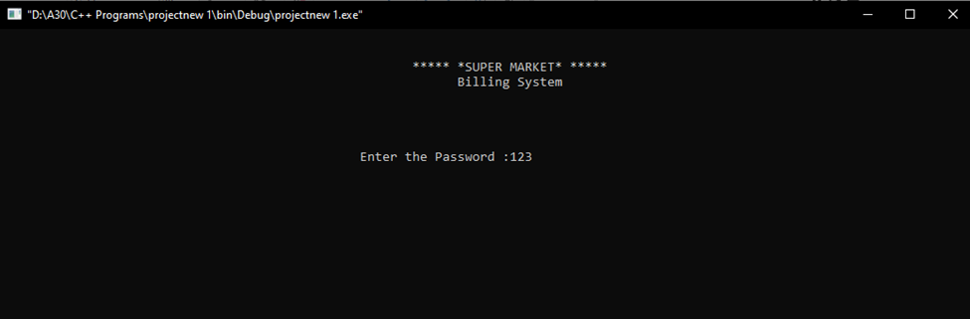

For the security purpose the password had been set up. After filling the correct password as shown above then the program asks for further unique information about person.

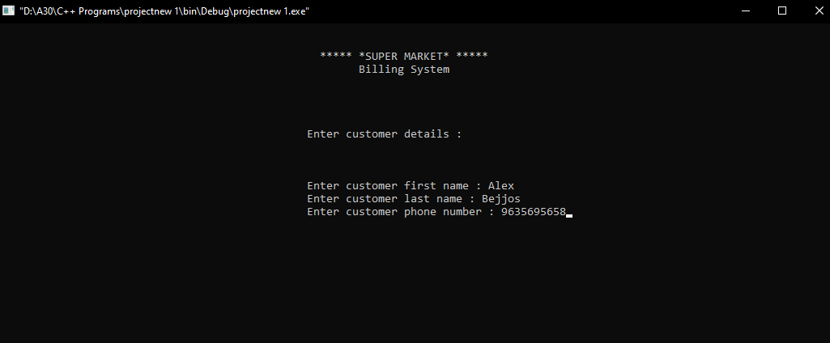

Example:- Name: Alex Bejjos and Ph no.:-9635695658

Next the main page is opened and it will ask for the required option.

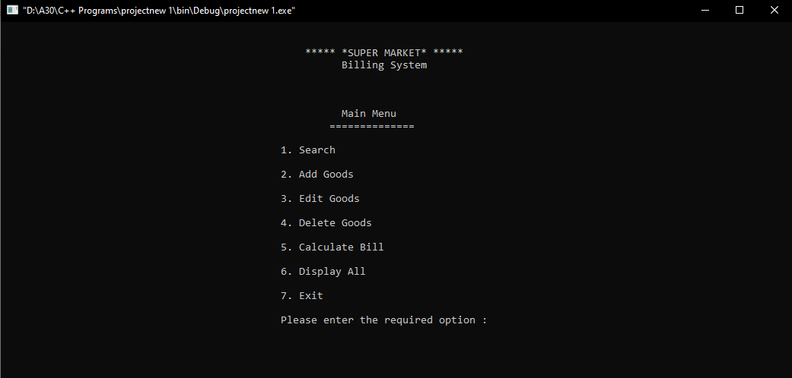

By pressing 2 a different layout screen is opened which will ask for the addition of articles in which article code, name, quantity and price to be added.

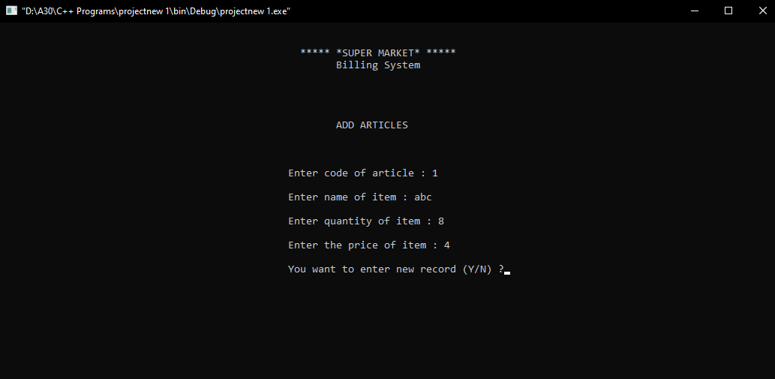

After adding the articles display option will display all the enteries as shown below. xczdfs

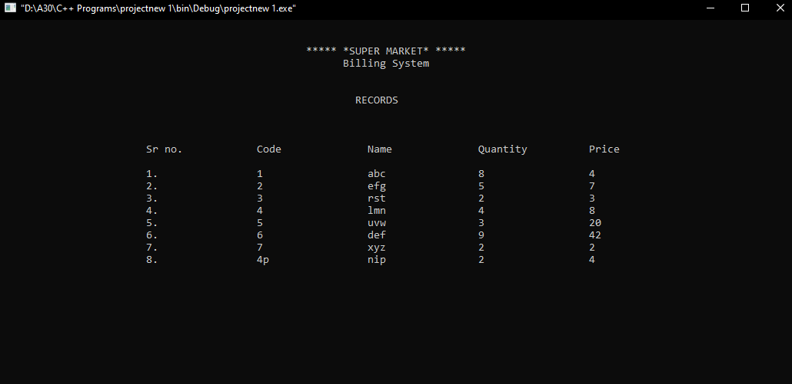

When the items/articles are added by edit option we can edit the item/articles. Like first of all the unique code of article is added then it will confirm the article by displaying it on screen and after that wwe can edit the article by quantity or by price.

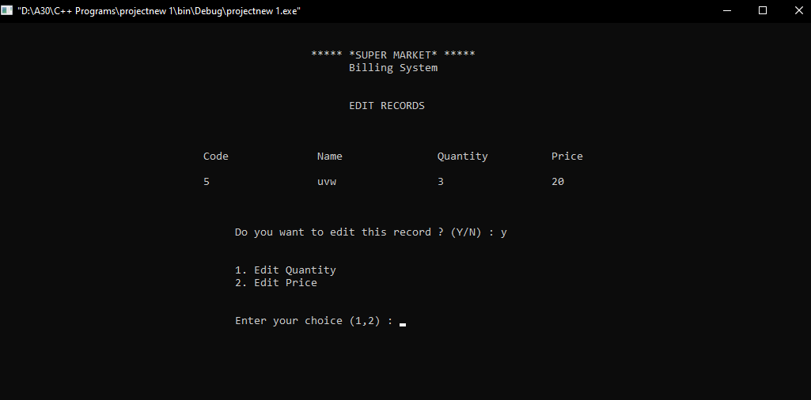

Then the item will be edited and it will display “**** Item Edited ****” and for deletion purpose enter the unique code of article then it will show “**** Item Deleted ****”.

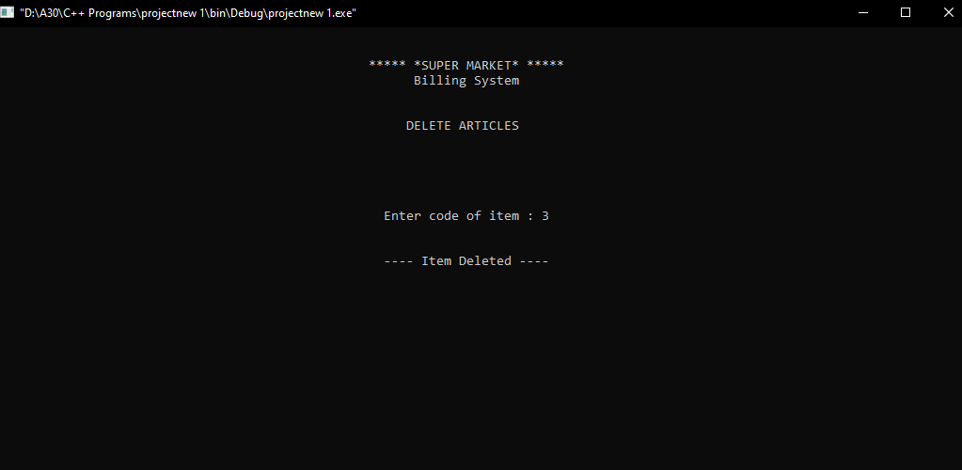

For calculating the bill option 5 is entered which will display gross amount with person’s name and phone number.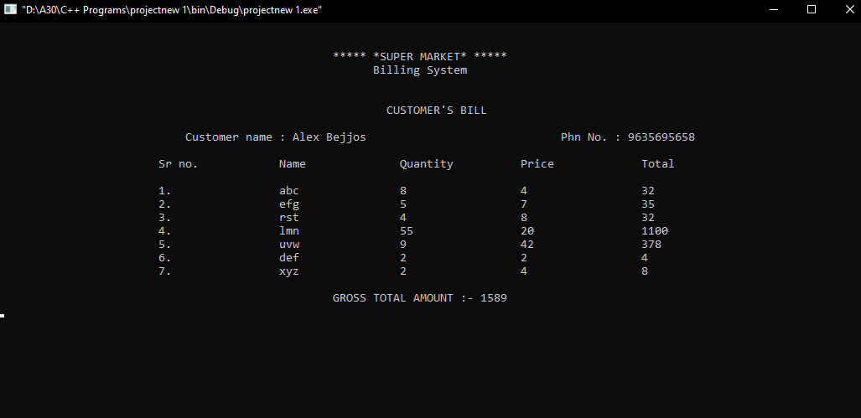

The search menu option can search articles by unique code or by name of articles then then item(s) will be displayed.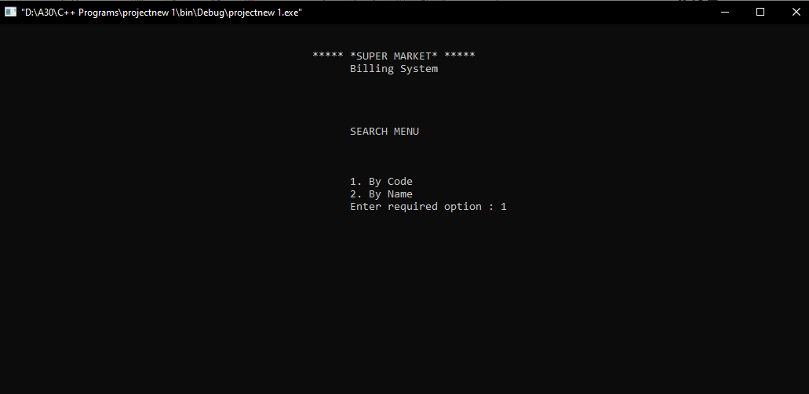

At last to exit program enter option 7.

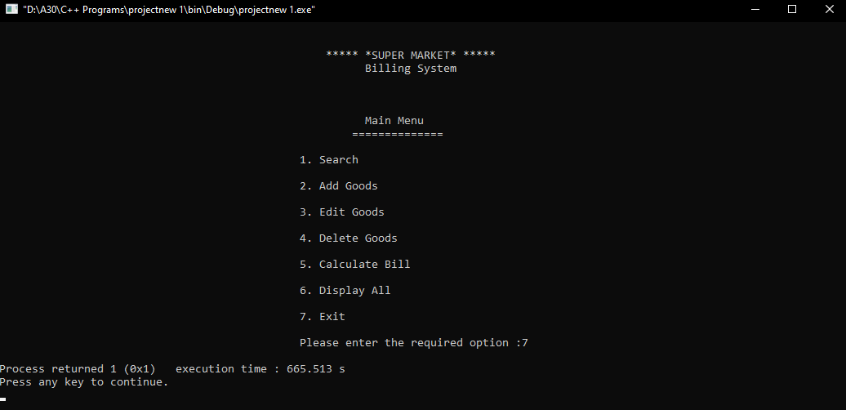

The details are recorded in file that is “Master Records” which can be viewed later on.

Future Scope

The main purpose behind this was to get an idea about the C++ features in real life useages. Further this can be made with Html, CSS and javascript an e-commerce website.

REFERENCES

[www.google.com](http://www.google.com)

[www.wikipedia.com](http://www.wikipedia.com)

[www.youtube.com](http://www.youtube.com)